Product Overview

Battery box
The screen displays the remaining power of battery box and charging status of earbuds.
Charge the battery box: the battery box is charged through the Type-C port. The number of “1 to 100” on screen means the remaining power from 1% to 100%.
It needs about 1.5 hour to get full charged.

Earbuds:
The earbuds use the touch button and consumer can control it by lightly touch.
Power on: the earbuds can be automatically turned on and start to pair when take its out of battery box, or long press its touch button for 2 seconds to turn it on.
Power off: the earbuds will be automatically turned off when put it back to battery box, or long press its touch button for 3 seconds to turn it off.
Paring: the blue light flashes when the earbuds have just been turned on, and then it enter into status that red&blue lights flash alternately. The left earbud will pair with right one first and the prompt tone “left channel”/”right channel” comes out from each earbud. The red&blue lights of right earbud keep on flashing and left earbud’s light will be shut off.
Pairing successful: open mobile phone’s BT menu and find “TWS-13”, click it to pair the earbuds with mobile phone.
(插图)

The prompt tone “connected” comes out and the right earbud’s indication light will be shut off once its are successfully paired with mobile phone. If the connection is broken off, the light will became reb&blue flash again and the tone “disconnected…pairing” come out.
Low-battery mode: red light blink and prompt tone “low battery” comes out.
In charging mode: red light of earbud is steady on and the screen displays the charging status. After fully charged, it’s switched to blue light, and then turned off after 10 seconds.
Charging time: about 1 hour.

Wearing Overview

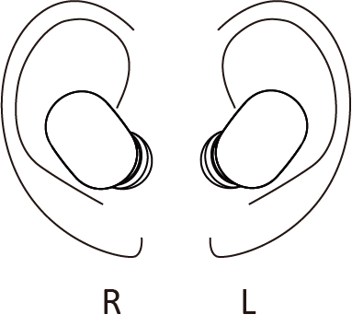
Function of Power button
NO. | Button operation | Status before execution | Status after execution | Prompt tone | LED status
1 | Long press for 3 seconds | Power on | Power off | Power off | Red light flash 3 times and turn off
2 | Long press for 2 seconds | Power off | Power on | Power on | Blue light flashs
 |  | Paired with iPhone | Enter into “Siri”
 |  | incoming call | rejection
4 | Single click | Music playing mode | Play/pause
 |  | incoming call | Pick up
 |  | On line | Hang off
 |  | dialing | Cancel the dialing
4 | Fast double click | Music playing mode | Left earbud: skip to next song  Right earbud: skip to previous song
 |  | before pair with mobile phone | Click right earbud to switch the language into English / Chinese
5 | Fast triple click | Music playing mode | Left earbud: increase the volume  Right earbud: reduce the volume

Note:
1.The left earbud will pair with right one automatically once its power on. If only one earbud connected with mobile phone, maybe the left&right earbuds haven’t successfully paired. Shut off the mobile phone’s BT and pair the left earbud with right one again. After left&right earbus are successfully connected, open mobile phone’s BT and pair it with earbuds.
2. If there is not BT device pair with the earbuds for over 5 minutes, the earbuds will be turned off automatically.
3. Don’t store the product into high temperature, nearby fire or touch with caustic chemical.
4. The headphone isn’t waterproof, please don’t use it in water or humidity environment.
5. Don’t disassemble the product by yourself, unprofessional operation might damage the product.
6. If don’t use the product for a long time, should charge it every month to keep the battery’s energy.
7. For your safety, don’t use the headphone when cross the street or walk on the road of heavy traffic. 8. High volume will hurt your hearing, please use the suitable volume and avoid to wear the headphones for long time.
9. The high frequency transmitter (such as WiFi, traffic light) will affect the signal of BT and cause it’s stuck or broken.

Parameters
Model: TWS-13
Wireless version:V5.0
Earbud battery: 3.7V 40mAh
Charger box: 3.7V 300mAh
Input of charger box: 5V, 0.3A
Playing time: about 3 hs (70% volume)
Standby time(after pairing): about 60hs
Earbuds size: 30*25*15 mm
Charger box size: 60.7*45.2*31 mm

