TWS EARBUDS
(Digimomo-J6)

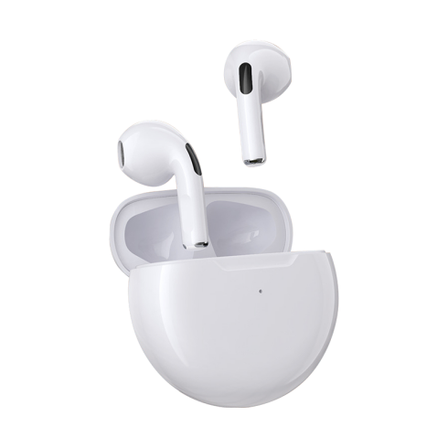
Parameters
Model: Digimomo-J6
Wireless version:V5.0
Earbud battery: 3.7V 30mAh
Charger box: 3.7V 185mAh
Input of charger box: 5V, 0.3A
Playing time: about 3 hs (70% volume)
Standby time(after pairing): about 60hs
Earbuds size:32*16.35*14.89mm
Charger box size: 50*21.5mm

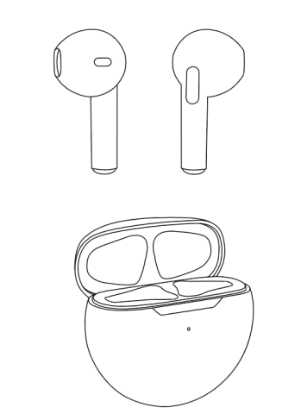
Speaker
Earbud：

Touch button
Charging touch point

Charging box：
Indication light

Type C port

Charging box
Charge the charging box: the charging box is charged through the Type-C port.
The red indication light flashs when the charging box is under charging, and it becomes steady red light when the charging box get fully charged.
It needs about 1.5 hours to get full charged.
When the charging box’ remaining power is less than 10%，the green indicator light will flash until it’s power off.

Earbuds:

The earbuds use the touch button and user can operate it by lightly touch the button area of earbud’s side.
Power on and pairing: the product built-in hall switch. When user open the charging box, the earbuds will be automatically turned on and enter into pairing status. Find the device name of DIGIMOMO-J6 on mobile phone’s Bluetooth menu, and click the device name to connect with mobile phone.（插图）
Turn on/off by touch button: when the earbuds are out of charging box, user can turn its on/off by long press the touch button for 3 seconds. When it’s turned off, the prompt tone is “du..du..du”, and the tone is light “du” when it’s turned on.
Low-battery mode: when the earbud’s remaining power is low, the prompt tone of “du..du” comes out and the earbud will be turned off after a while.
Charging mode：when the earbuds is in the charging box, close the charging box to shut off the connection and the earbuds enter into charging status. And the charging will be shut off when open the charging box.
In charging mode, green indication light of charging box is steady on and the light is off when the earbuds get fully charged.
Charging time: it’s about 1 hour to get the earbuds fully charged.

How to wear the earbuds

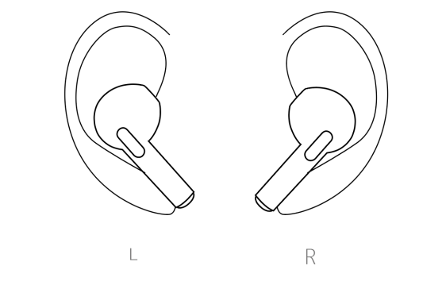

Function of Power button
NO. | Button operation | Status before execution | Status after execution | Prompt tone | LED status
1 | Long press for 3 seconds | Power on | Power off | “du-du-du”
 |  | Power off | Power on | “du”
2 | Long press for 2 seconds | Paired with iPhone | Enter into “Siri”
 |  | incoming call | rejection
3 | Single click | Music playing mode | Play/pause
 |  | incoming call | Pick up
 |  | On line | Hang off
 |  | dialing | Cancel the dialing
4 | Fast double click | Music playing mode | Left earbud: reduce the volume  Right earbud: increase the volume
5 | Fast triple click | Music playing mode | Left earbud: skip to previous song  Right earbud: skip to next song

Note:
1.The left earbud will pair with right one automatically once its power on. If only one earbud connected with mobile phone, maybe the left&right earbuds haven’t successfully paired. Shut off the mobile phone’s BT and pair the left earbud with right one again. After left&right earbus are successfully connected, open mobile phone’s BT and pair it with earbuds.
2. If there is not BT device pair with the earbuds for over 5 minutes, the earbuds will be turned off automatically.
3. Don’t store the product into high temperature, nearby fire or touch with caustic chemical.
4. Please don’t use it in water or humidity environment.
5. Don’t disassemble the product by yourself, unprofessional operation might damage the product.
6. If don’t use the product for a long time, should charge it every month to keep the battery’s energy.
7. For your safety, don’t use the headphone when cross the street or walk on the road of heavy traffic. 8. High volume will hurt your hearing, please use the suitable volume and avoid to wear the headphones for long time.
9. The high frequency transmitter (such as WiFi, traffic light) will affect the signal of BT and cause it’s stuck or broken.

