Features
Compatible with all Bluetooth enabled devices. Built in microphone for hands free phone calls.
Headsets can be removed to facilitate washing the headgear. (Speaker are not waterproof)
Charge anywhere with universal micro-USB cable (included).
Stream your music wirelessly with no dangling cables.
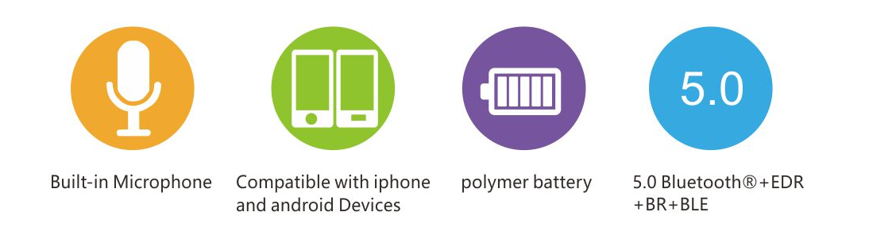
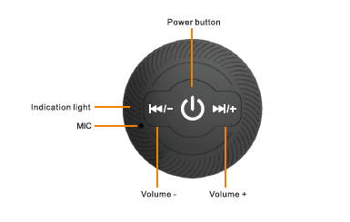

Power On/Off
Power On: long press the power button for 4 seconds until Red&Blue light fashes alternately, the speaker will say "power on".
Power Off: long press the power button for 4 seconds until the LED light shuts off. The speaker will say "power off".

Music
Short press the power button to Play/Pause the music.
Short press the Volume + button to play next song, long press it to increase the volume.
Short press the Volume - button to play previous song, long press it to reduce the volume.

Charging
Remove the controlling speaker out from the headgear, you can see the charge port and charge it by accessary cable. The LED light is RED and will shut off after the battery is fully charged.

Specifications
Bluetooth version: 5.0
Speaker drivers: 30MM,32Ω
Output Power: 2Wx2sets
Frequency: 2.402 GHz--2.480GHz
Transmission distance: 10 meter (30 feet)
Battery: Li-Ion 3.7V/180 mAH
Play-time: 8-10 hs

Pairing to Music Wear
After power on, the speaker enter into pairing mode. Search the Bluetooth name "Music Headwear" on mobile phone's Bluetooth menu and click it to pair.
The speaker says "connected" when pairing successfully, and says "disconnected" when shut off the pairing.
After the first pairing, the speaker will connect with your mobile phone automatically when it's turned on next time.
The headphones will turn off automatically in no pairing for over 5 minutes.

Calls
Short press power button can pick up/hang off the incoming call and cancel the dialing.
Long press power button for 2 seconds to reject the incoming call.
At pairing status , double click power button to call the last dialing number.

Light
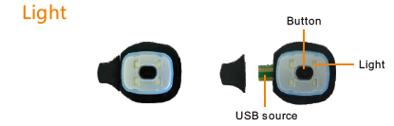

1.Operated by 1*250 mAhLithium non-replaceable battery (included).
2. Take out the light from the hat, remove the cap and plug into USB power source to charge the battery.
3. Light flashes when it is being charged. Light disappears when it is fully charged.
4. Press the button to turn on the light with three levels of brightness.
5. light time: first level: 80 mins second level: 150mins third level: 240 mins

Install the headphones
The headsets are only for headgear with specially customized slots.
Inset right speaker into A slot and slide to B slot through the rear inner layer of headgear.
Notice: the headsets' wire is hided in the back of headgear.
Slightly pull it out from B slot, and keep another speaker outside of A slot.
Install the speakers from outside and make both speakers fixed on the slots.
Check if the headphones fit correctly. The edge of slots should not be visible.
Correct: The edge is invisible. Wrong: The edge is visible.

Washing instruction
You must remove the speakers out from the beanie/headband before washing it.
Take out one speaker from A slot, push another speaker inside the inner layer of headgear and slide to A slot and take it out.
Once removed out, the headphones will like below picture:
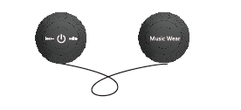
Wash beanie/headband in correct method, do not use bleach. Use biodegradable soap if possible.

Precaution
1. Don't store the product into high temperature, nearby fire or touch with caustic chemical.
2. The headphone isn't waterproof, please don't use it in water or store it at humidity environment.
3. Don't disassemble the product by yourself, unprofessional operation might damage the product.
4. Cautiously use the headphone when cross the street or walk on the road of heavy traffic.
5. High volume will hurt your hearing, please use the suitable volume and avoid to listen it for long time.
6. Charge the headphone termly to keep the battery energic if don't use it for long time.
7. Don't stare into light beam or do not point the beam to eyes. This is harmful for the eyes!

